As a Communication and Psychology double major, I undertook a number of multidisciplinary research projects during my undergraduate years, through which my keen interest in the dynamic interactions between the human brain and mediated messages has been promoted step by step. However, through my professional and lab experiences, I realized that, without strategic use of data, any attempt to understand this complex topic is in vain. I am therefore prompted to pursue a Master’s of Arts degree in Quantitative Methods in the Social Sciences (QMSS) at Columbia University, with an experiments focus, to equip myself with knowledge and skill sets necessary for exploration at the intersection of communication, technology and neuroscience. 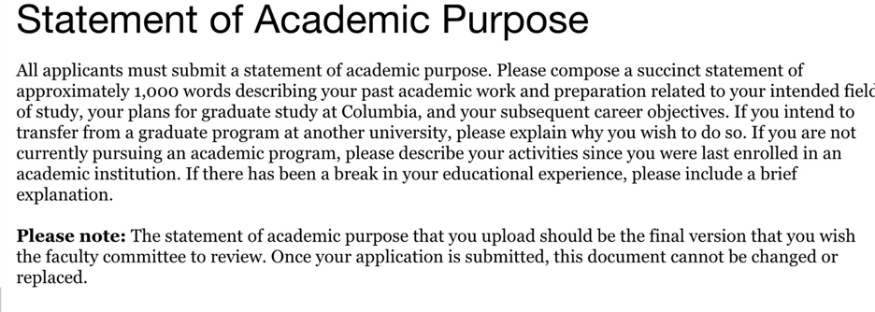

During my internship at Tencent Online Media Group in 2017, I leveraged my writing skills to produce news stories for the Global News Channel. As a news writer, the most challenging parts are processing large amounts of information at a high speed while identifying and catering to user preferences. I paid close attention to user responses to my news articles including their comments and page views, which led to my discovery that Tencent users were into articles with visual aids and historical anecdotes. I shared my observations with my colleagues and improved my articles accordingly, which increased the number of reads by over fifty times. I was impressed by the power of understanding human decisions in order to increase product or service effectiveness, and started to wonder how this process could be automated through machine learning algorithms.

Triggered by my internship experience, I desired to acquire more knowledge about data science. During XXX, I found the opportunity to work as a research assistant at the Media Neuroscience Lab at UCSB, where I had my first exposure to rigorous scientific experiments involving data analytics. I mainly worked on two ongoing projects, one of them was a Functional magnetic resonance imaging (fMRI) study aimed at investigating brain networks underlying cognitive and perceptual processing during video game play, and the other focused on developing a narrative analysis system so as to examine the dynamics between moral domains in mediated narratives and audience response. In the process, I learned how to set up fMRI, run participants at the computer lab, and code categories of moral information in news data using Excel. Most importantly, I gained valuable insights into how automated computational methods and hand coding could be used for content analysis of news articles, as well as how neuroimaging technology could be harnessed to enrich mass communication research from a neurophysiological perspective.

With the knowledge gained in the lab, I initiated my first research project when I took the course *Laboratory in Advanced Research Methods*. I led a group of four to investigate the relationship between perceived self-esteem and likability of online profiles in an online dating context, with raters’ gender and own self-esteem as two moderators. We worked step by step from brainstorming research topics, conducting literature reviews, designing experiments, recruiting participants, analyzing data and visualizing the results using SPSS, to writing final research paper and delivering a poster presentation. This experience made me realize that, in addition to solid research knowledge and analytics skills, the capability of handling a great deal of tedious and repetitive work is crucial to any researcher.

Intrigued by the use of lab experiments to establish causal inferences, I started my independent research project under the supervision of Dr. Rene Weber at the Media Neuroscience Lab. As a bilingual, I am interested in how juggling two tasks involving media use in different languages affect task performance among bilingual college students. Through the method of literature review, I realized that this area of research was in its incipient stage and thus decided to design an exploratory study. I constructed an online picture-word matching task accompanied by audiobook clips in English, Mandarin and Spanish using PsychoPy, a software package in Python. To smooth the designing process, I programmed an image sorter that could extract words from file names to help me organize numerous pictures. So far, I have collected data from 80 participants and am currently analyzing the data using the statistical program R. An extended abstract of the study has been submitted to International Communication Association and findings and will be presented at ICA’s 2019 conference. I hope the study will inform media-utilization behaviors among bilinguals and provide customer insights for digital media companies.

In addition to my rich research experiences, I am also taking online courses in programming (R and Python), probability and data to sharpen my quantitative skills to prepare for the QMSS program. Furthermore, my solid educational background in XXX also makes me a promising candidate for your program. Throughout my undergraduate years, I took a variety of courses that allowed me to gain a systematic understanding of psychology, neuroscience and communication from different perspectives, for example, organizational communication, small group communication, cognitive psychology and social networks.

I was especially fond of the topics covered in the social networks class, where I was introduced to emergent structures, relational dynamics and networks across levels, types and contents. I am curious about how to maximize the benefits of this heightened connectivity. If admitted, I plan to take advantage of the course on Social Network Analysis taught by the program director of QMSS, Dr. Greg Eirich, to receive high quality training on network analysis, manipulation and visualization using statistical software. Moreover, I aspire to further explore my current research topic on bilingualism and media multitasking, a near-ubiquitous behavior in the modern world. After reading the book on field experiments written by Dr. Donald Green and Dr. Alan Gerber, I was attracted by and achieved a deeper understanding of field experimentation including its design, data analysis and results interpretation. Thus, in my graduate study, through XXX, I intend to learn more about field study approaches such as interviewing which can be utilized in my current study to elicit detailed information from participants and acquire more in-depth insights into the topic.

My plan after graduating from QMSS is to pursue a doctorate in communication. I hope to conduct original research with more sophisticated methods in the field of Communication, focusing on multimedia processing and cognitive responses to media effects. I aspire to bring what I would learn back to my home country in the long term, becoming a professionally trained scholar examining XXX. Given its extensive alumni networks and affluent academic resources, I have no doubt that QMSS at Columbia University will be an indispensable step towards my academic and career goals.